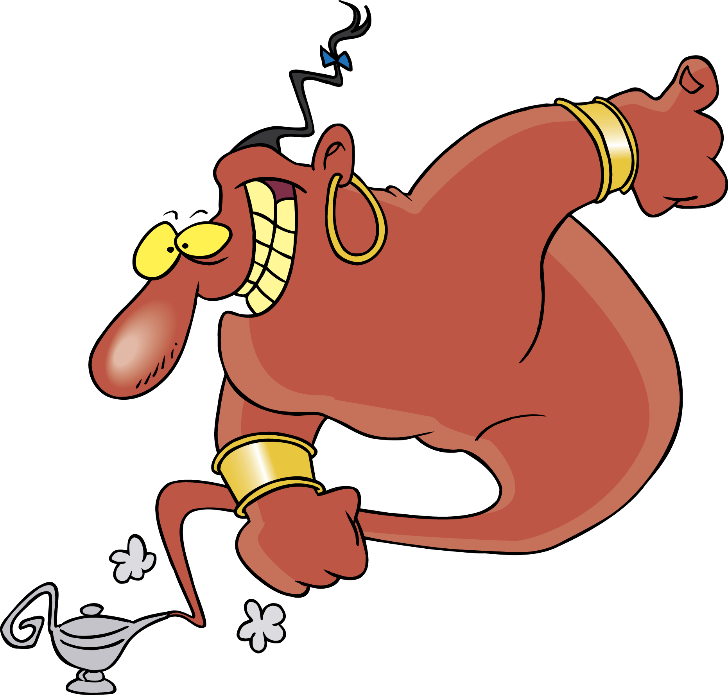
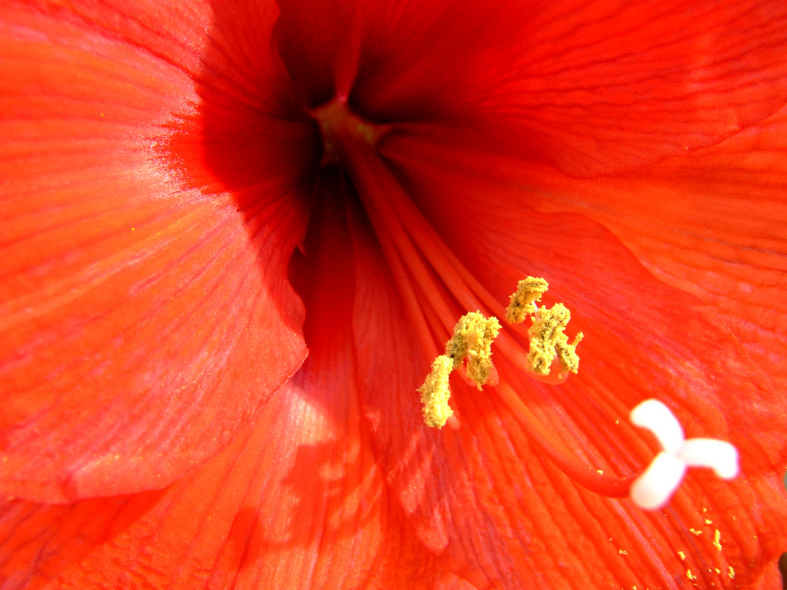
Great Ideas
Written By:

The genie gives you a wish.
What is your wish?

